Successful Debulking of Mitral Valve Vegetation using AngioVac: A Case Report

Authors: Terezia Petraskova DO, Anirudh Palicherla MD, May Li-Jedras DO, Muhammad Ghallab MD, Sean Kennedy DO, Qais Radaideh MD, Himanshu Agarwal MD, Venkata Alla MD

**Background:**

For those withinfective endocarditis, open heart surgery is typically reserved for those with persistent bacteremia, large vegetation size or abscess formation. However, it is associated with risks and not feasible in certain patient populations. A minimally invasive procedure involving the AngioVac device is an alternative approach to decrease the likelihood of severe, life-threatening complications.

**Clinical Case:**

A 37 year old male with a past medical history of IV methamphetamine abuse was admitted with bilateral hip and back pain, and petechial rash. Exam notable for Osler nodes and Janeway lesions. Further workup revealed Methicillin-resistant Staphylococcus aureus bacteremia. Trans-esophageal echocardiography revealed a 1.2 x 0.7 cm vegetation on anterior mitral leaflet with trace mitral valve regurgitation. Patient was evaluated by multi-disciplinary team approach and due to subarachnoid hemorrhage, patient was deemed prohibitive risk for surgery. Patient remained persistently bacteremic despite appropriate antimicrobial management. Thus, the decision was made to pursue debulking of mitral valve vegetation using AngioVac. Under TEE guidance and with atrial trans-septal approach, the vegetation was visualized and aspirated with decreased size in vegetation. Additionally, to decrease the risk of embolic phenomenon, SENTINEL cardio-embolic protection was utilized.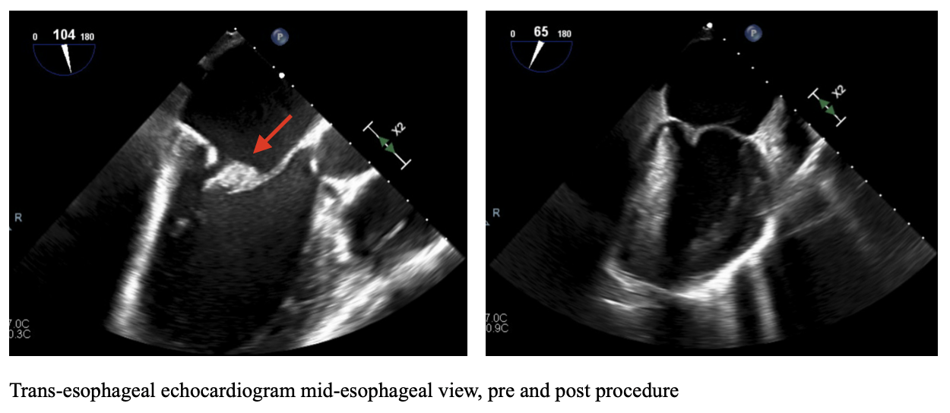

**Discussion:**

AngioVac is a minimally invasive aspiration system FDA approved for emboli, thrombi or vegetations in the right heart or venous circulation and often reserved for non-surgical candidates. Data for AngioVac in the use of arterial circulation or left heart is limited, with few cases reported in literature. Risk of use include fragmentation and subsequent embolization, and technical expertise is required for successful debulking. We demonstrate novel use of AngioVac of large mitral valve vegetation debulking in patient with prohibitive risk of surgery. AngioVac is an innovative, alternative, less invasive procedure for high risk and non-operative patients in setting of mitral valve endocarditis.