A Rare Vascular Connection: Right Coronary Artery to Coronary Sinus Fistula
Authors – Malhotra, A., MBBS¹, Ahmad, S., MBBS¹ *
- Division of Cardiovascular Medicine, University of Nebraska School of Medicine

Background: Coronary artery fistulas (CAFs) affect 0.002% of general population. Right coronary artery (RCA)–coronary sinus (CS) fistulas account for only 7% of all CAFs (1). RCA-CS fistulas can present with angina, congestive heart failure, and arrhythmias (2).
Case: A 69-yr-old male with history of paroxysmal atrial fibrillation presented to ER with sudden onset angina. His examination was unremarkable, and EKG showed normal sinus rhythm with incomplete RBBB. His Troponin-I and BNP levels were mildly elevated. TTE showed bi-atrial enlargement, mildly dilated right ventricle, and normal biventricular systolic function.
Discussion: Patient was appropriately treated for ACS and underwent left heart catheterization that revealed no focal obstructive coronary lesions. However, it showed diffuse, severe ectasia of RCA with possible fistulous connection with CS (Fig 1a-b). Multidetector computed tomography (MDCT) confirmed a diffusely dilated, tortuous, dominant RCA measuring up to 15 mm in diameter with normal origin and fistulous distal termination in the coronary sinus (Fig 1c-e). Right heart catheterization showed normal PA pressures and a significantly high RA-low RA step up (58% 66%) suggestive of an atrial level left-to-right shunt with calculated Qp/Qs ratio of 1.36. His anginal symptoms were deemed to be related to “coronary steal” from the large size RCA-CS fistula (3). He underwent successful bovine pericardial patch repair of fistulous connection between RCA and CS proximal to CS opening in RA. Post-op course was complicated by acute RV dysfunction that improved with supportive care and patient was successfully discharged to rehab.
Conclusions: RCA-CS fistula are rare and can present with anginal symptoms due to underlying coronary steal. Symptomatic patients should be timely evaluated for percutaneous or surgical repair.
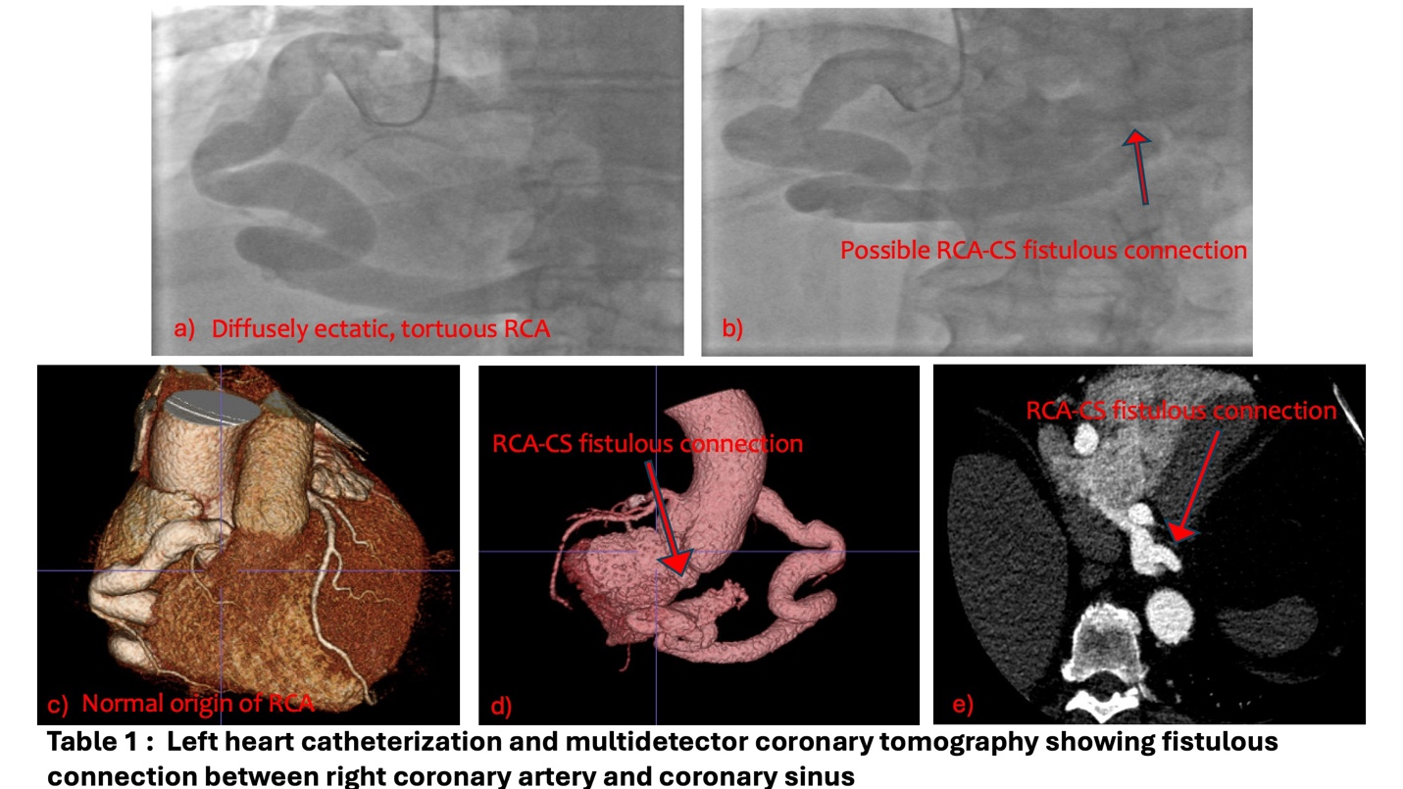

References:
- Yuan M, Bai WJ, Li CM, Rao L. Fistula between the right coronary artery and coronary sinus: a case report and literature review. Anatol J Cardiol. 2017;18(1):79-80. doi:10.14744/AnatolJCardiol.2017.7868
- Gowda RM, Vasavada BC, Khan IA. Coronary artery fistulas: clinical and therapeutic considerations. Int J Cardiol. 2006;107(1):7-10. doi:10.1016/j.ijcard.2005.01.067Gowda
- Challoumas D, Pericleous A, Dimitrakaki IA, Danelatos C, Dimitrakakis G. Coronary arteriovenous fistulae: a review. Int J Angiol. 2014;23(1):1-10. doi:10.1055/s-0033-1349162

