A rare case of ventriculobronchial fistula caused by an epicardial defibrillator patch

Sai Vikram Alampoondi Venkataramanan MBBS, John Windle MD, Anthony Castleberry MD

Background

Epicardial patch defibrillators (EPDs) were commonly implanted in the 1990s for secondary prevention of sudden cardiac death. Despite being largely obsolete, some EPDs remain in patients and can cause late complications. This case highlights such a scenario.

Case

A 75-year-old female with a history of cardiac arrest 30 years ago and heart failure with preserved ejection fraction presented with shortness of breath and left leg swelling. She had idiopathic ventricular fibrillation in 1992, treated with an EPD (Picture 1A), later replaced by a transvenous ICD.

She was diagnosed with left femoral deep venous thrombosis and bilateral pulmonary embolism and started on therapeutic anticoagulation. She experienced massive hemoptysis, leading to respiratory and cardiac arrest, but was resuscitated. A CT angiogram showed no active bleeding but noted the EPD was close to the lower lobe of the left lung. Upper gastrointestinal endoscopy showed no active bleeding. Bronchoscopy revealed clots in the left lower lobe. Despite empiric bronchial artery embolization, hemoptysis persisted. A repeat bronchoscopy showed reaccumulation of clots. A repeat CT angiogram indicated contrast extension into the ventricular myocardium near the EPD but no lung spillage suggestive of pseudoaneurysm (Picture 1B).

She was transferred to our institution for further evaluation. A coronary angiogram revealed normal arteries, while a left ventriculogram revealed contrast extravasation through the lateral wall (Picture 1C). An urgent surgery revealed two EPDs: anterior and lateral. The lateral EPD had eroded into the ventricle, creating a ventriculo bronchial fistula (Picture 1D). The lateral EPD was removed (Picture 1E); the anterior EPD was left in place (Picture 1F). The ventricular defect was debrided and repaired. Postoperative recovery was successful, with no further hemoptysis, and the patient was discharged to a rehabilitation facility.

Discussion

EPDs are no longer used due to high failure rates and complications like scar formation and constrictive pericarditis. However, patients with EPDs from the 1990s may present with delayed complications. Accurate diagnosis using multimodality imaging and early management are crucial to reduce morbidity and mortality.

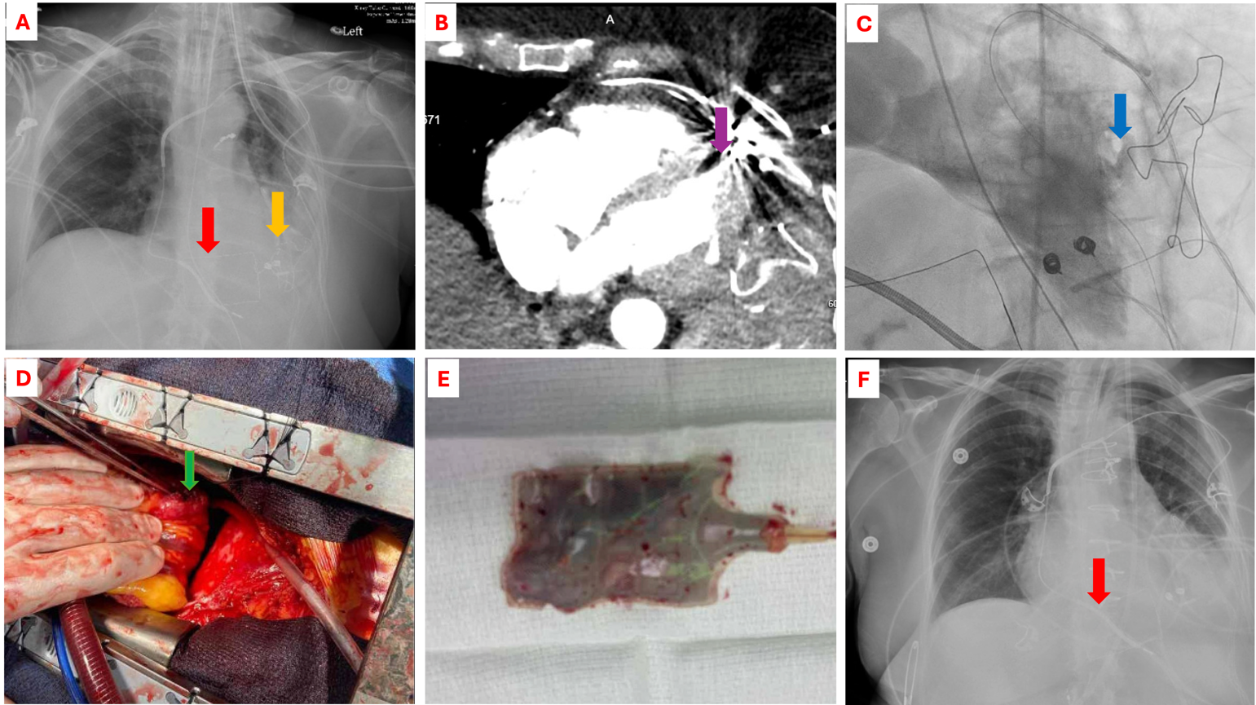

Picture 1. A. Anterior (red arrow) and lateral (yellow arrow) EPD on Xray. B. Pseduoaneurysm. C. Contrast extravasation on ventriculogram. D. LV fistula. E. Explanted EPD. F. Anterior EPD (red arrow) still present on Xray.

