Title:
Gender Differences in Clinical Outcomes of Percutaneous Coronary Intervention for Chronic Total Occlusion: A Meta-Analysis

Authors:
Muhammad Asim Shabbir, MD¹; Mohammad Hamza², MD, Edward O’Leary, MD¹.
- University of Nebraska Medical Center, Omaha, NE
- Guthrie Medical Center, PA

Background:
The impact of gender is unclear in clinical outcomes of patients undergoing percutaneous coronary intervention (PCI) for chronic total occlusion (CTO). We performed an updated meta-analysis to understand it.

Methods:
We collected 16 studies from PubMed and Embase. Inclusion criteria: age > 18 years, studies with PCI for CTO having outcomes stratified by gender. Exclusion criteria: prior CABG. Clinical outcomes were in-hospital major cardiovascular events (MACE): bleeding, stroke, cardiovascular death; follow-up (≥ 6 months) all-cause mortality and myocardial infarction (MI); and procedural success.
Analysis was done using CRAN-R software using meta package. Mantel-Haenszel method with random effects model was used to calculate pooled odds ratio (OR) for each outcome with 95% confidence interval (CI) for statistical significance. Higgins I-squared (I²) statistic was used to evaluate heterogeneity (Fig 1).

Results:
We used men as an experimental group and women as a control group. Men did not show any significant superiority in terms of MACE (OR = 0.93; CI = 0.73 – 1.19, p = 0.59, I² = 73.6%), follow-up all-cause mortality (OR = 0.86; CI = 0.63 – 1.18, p = 0.36, I² = 50.3%), follow-up MI (OR = 0.8; CI = 0.6 – 1.05, p = 0.11, I² = 0.0%) or procedural success (OR = 1.04; CI = 0.90 – 1.21, p = 0.53, I² = 60.7%).

Conclusion:
Men and women undergoing CTO PCI have similar outcomes. Larger prospective data is needed to validate the findings.

A: Major Adverse Cardiovascular Events B: Mortality
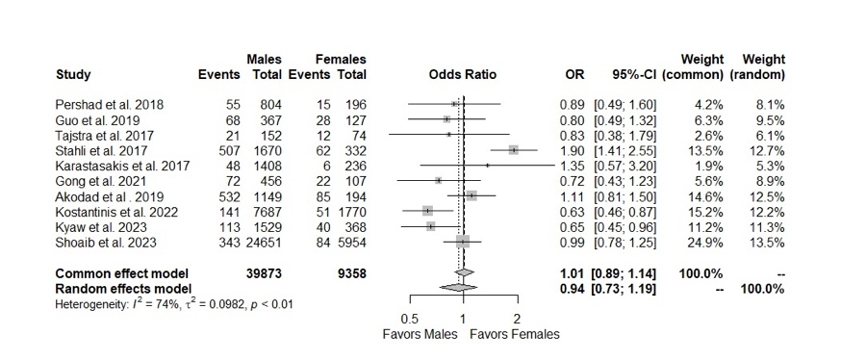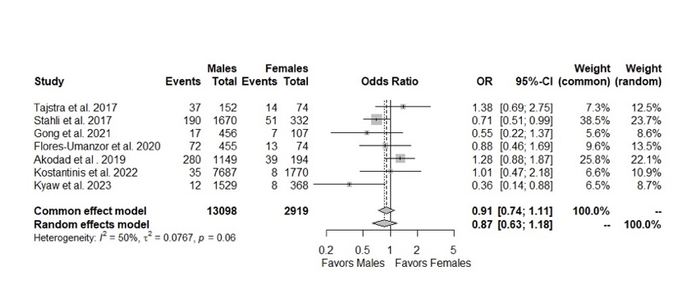
B: Myocardial Infarction D: Procedural Success
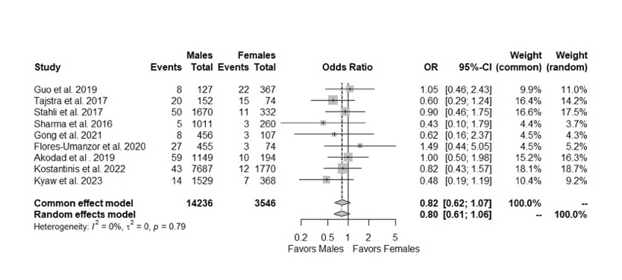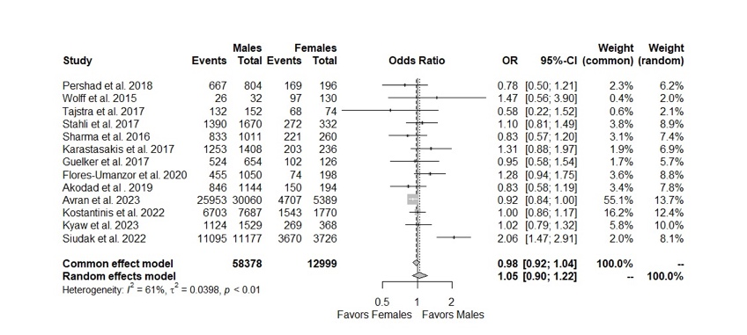

Fig 1: Clinical outcomes of MACE (A), mortality (B), MI (C), procedural success (D)
MACE=Major adverse cardiovascular events, MI= myocardial infarction

