**TAVR Outcomes in Patients with Severe Aortic Stenosis and Cardiac Amyloidosis: A Systematic Review and Meta-Analysis**

Presenting Author: Soban Ahmad, MD

Affiliation: Division of Cardiovascular Medicine, University of Nebraska Medical Center.

**Background:**

Cardiac amyloidosis (CA) results from the deposition of abnormally folded protein

fibrils, leading to restrictive cardiomyopathy, valvular heart disease, and arrhythmias. Many patients with aortic stenosis (AS) have concomitant CA (AS-CA). We conducted this

systematic review and meta-analysis to compare outcomes of transcatheter aortic

valve replacement (TAVR) in patients with AS-CA and AS alone.

**Methods:**

We searched PubMed, Embase, Google Scholar, ClinicalTrials.gov, Scopus, and

Cochrane Central Register of Control Trials (OVID) for relevant studies from inception

through January 20, 2024. Studies exploring outcomes in adult AS patients with and without

CA who underwent TAVR were included in this analysis.

**Results:**

Five studies comprising 246,897 patients (AS-CA 638; AS alone 246,259) were identified. Our analysis indicated that post-TAVR 30-day and 1-year survival rates were comparable between patients with AS-CA and AS alone. However, patients with AS-CA had a higher risk of post-TAVR acute kidney injury (RR=1.95, 95% CI 1.35-2.80, P=0.0003). The risk of other post-TAVR complications, including major bleeding, vascular complications, stroke, and new pacemaker implantation was similar between AS-CA and AS alone cohorts. (Figure 1)

**Conclusion:**

In patients with concomitant AS and CA, TAVR is a safe intervention and offers a mortality benefit similar to that of patients with AS alone.

**Figure 1: TAVR Outcomes in AS-CA vs. AS alone**

**a. 30-day mortality**

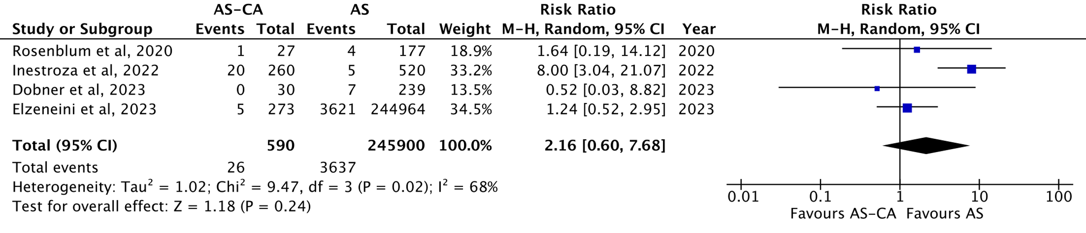

**b. 1-year mortality**

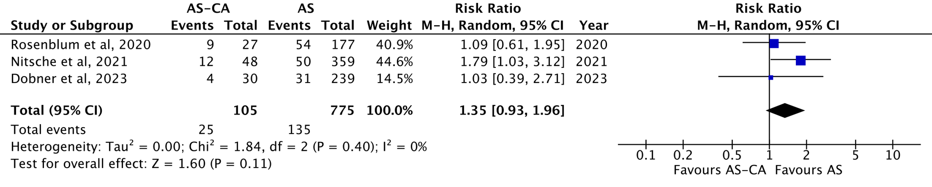

**c. Major bleeding**

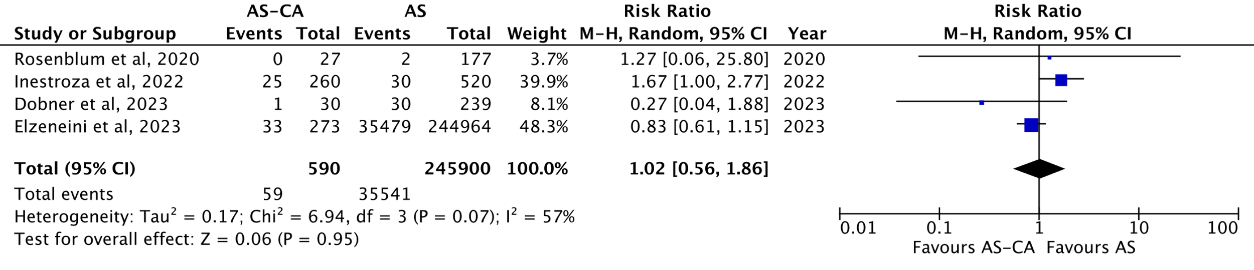

**d. Vascular complications**

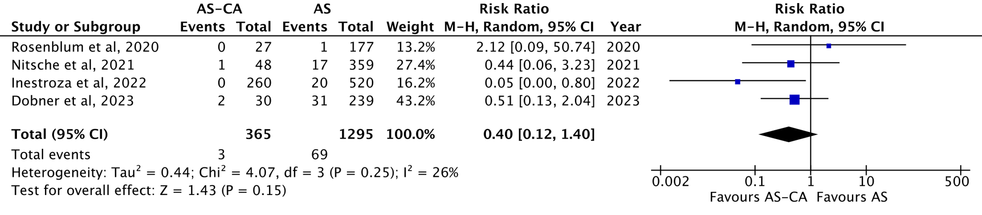

**e. Stroke**

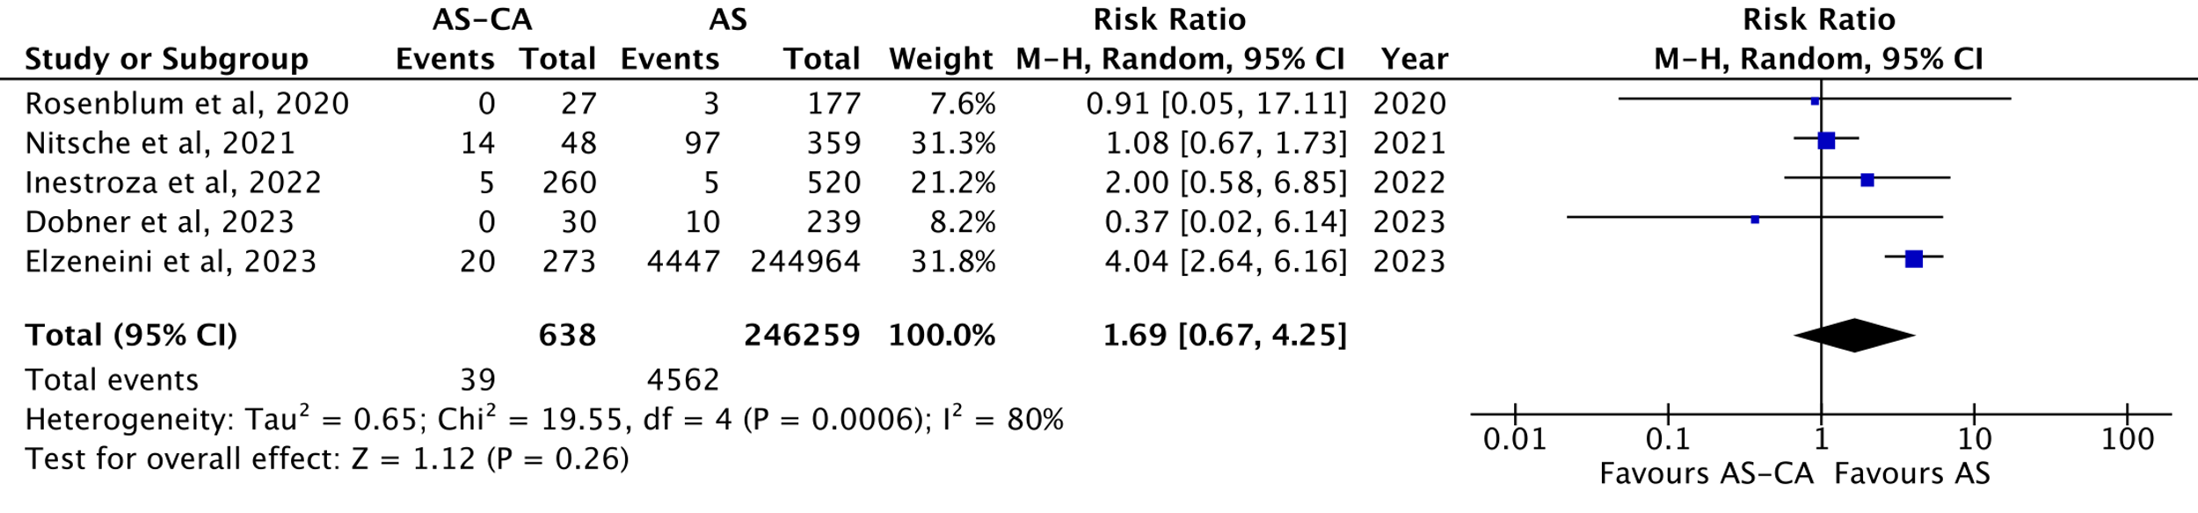

**f. PPM implantation**

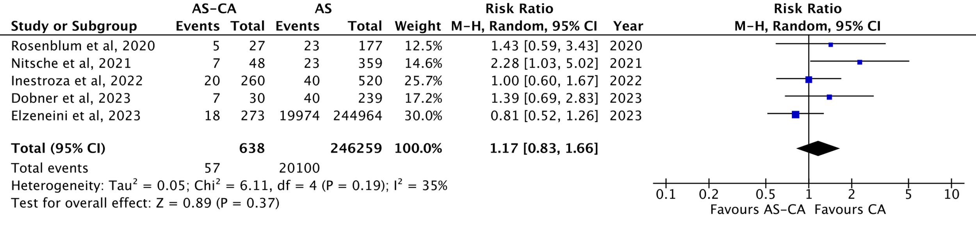

**g. AKI**

