A Rare Case of Coronary Anomaly Consisting of Right Coronary, Left Circumflex and Left Anterior Descending Arteries Arising from a Single Right Ostium

Introduction
The occurrence of coronary arteries originating from a single coronary ostium is an exceptionally rare phenomenon, with a prevalence of 0.02%-0.06%.

Description of Case
61-year-old male with a history of coronary artery disease (CAD) post-angioplasty and stent placement in 2008, presented with decreased ejection fraction (EF) of 40%, down from >55% a decade ago. Notable family history of CAD. CCTA revealed extensive atherosclerosis with moderate obstruction and single coronary ostium arising from the right cusp, with the right coronary artery, left circumflex, and left anterior descending arteries originating from this single right ostium. Coronary angiogram revealed mild diffuse disease in the left anterior descending artery, 50% stenosis in the left circumflex, and an ectatic right coronary artery with 60% in-stent restenosis. Medical management with GDMT was suggested.

Discussion
The presence of all vessels arising from a single right ostium without other congenital abnormalities is exceedingly rare. While most coronary artery anomalies are incidental and benign, complications like angina, sudden cardiac death, and arrhythmias can occur, especially when an artery is compressed between the pulmonary artery and aorta. Optimal visualization is achieved through coronary CT and coronary angiography. Treatment involves surgical or medical after risks versus benefits discussion between the patient and the physician.

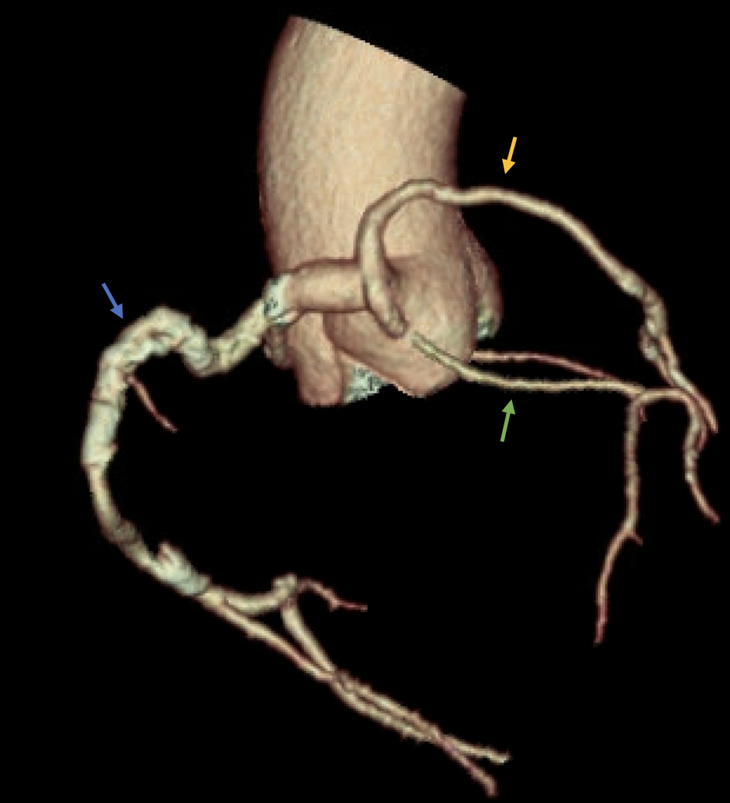
Figure 1: CCTA showing a single coronary ostium arising from a right coronary cusp. Right coronary Artery (blue arrow) is the dominant vessel. Left anterior descending (yellow arrow) and Left circumflex artery (green arrow) arise from the right coronary artery.

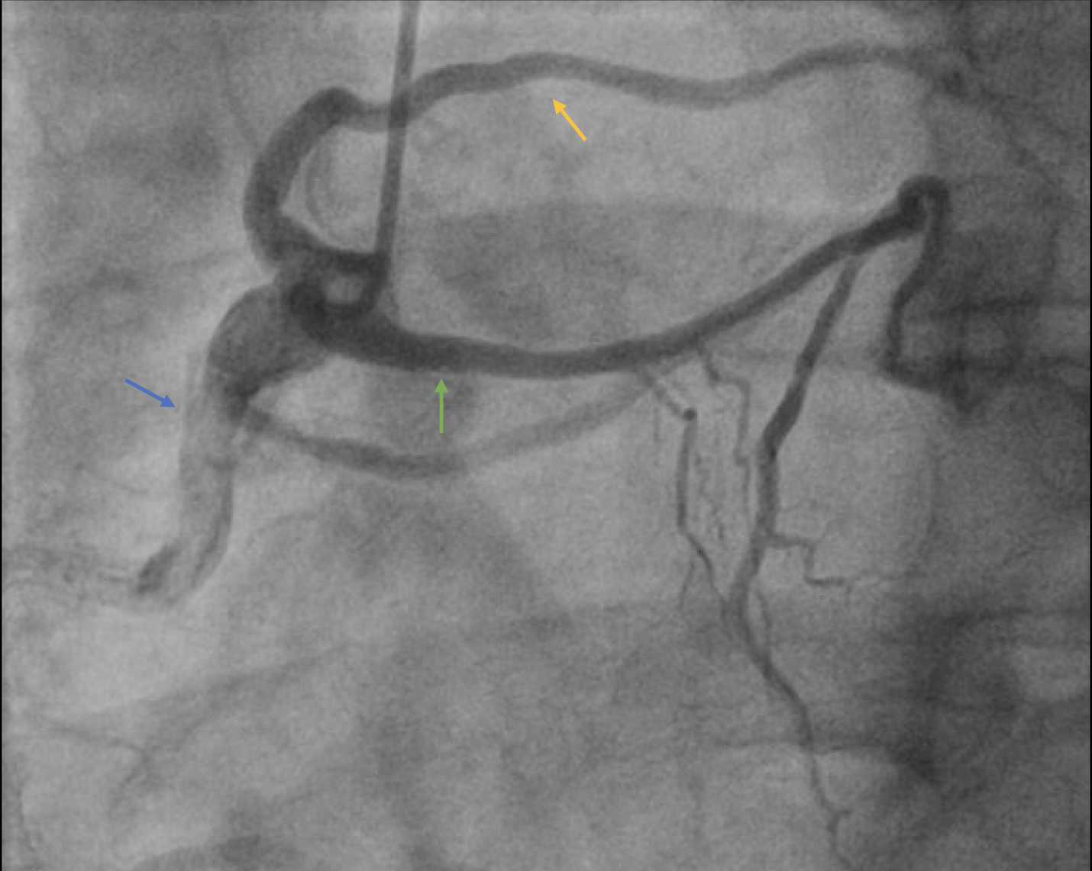
Figure 2: Coronary Angiogram showing LCx (green arrow) and LAD (yellow arrow) originating from RCA.

